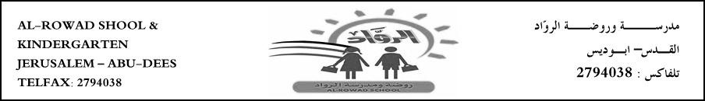

Name:………………………. 5th grade (A/B)

**English language exam**

**Q1- read the following text then answer the questions: (18/ )**

The Zoological Society of London (ZSL) tries to breed endangered species and prevent animals from becoming extinct. This is important work because we can learn a lot from animals but when **they** are extinct, they are gone forever.

In 2007, the ZSL opened Gorilla Kingdom, a wonderful new gorilla enclosure at London Zoo, with waterfalls, warm rocks, hills, plants and birds. Today, four gorillas live in Gorilla Kingdom.

Bobby is 26 years old. **He** came to London Zoo from Rome Zoo in 2003. Bobby was a wild animal when he was a baby, but he performed in a circus until the late 1980s. It takes time for Bobby to get to know new people, but he always makes friends in the end!

Zaire is 34. She has been at London Zoo since 1984. She is very playful, but she is sometimes naughty, too

1. What does the ZSL stand for?

1. Why is breeding animals important?
2. How many gorillas live in Gorilla Kingdom?
3. Zaire has been at London Zoo since …………………….
4. **Answer with T or F:**
5. Zaire is 35 years old ------
6. Bobby used to perform in a circus --------
7. Bobby came to London Zoo from Spain -------
8. **What does the underline words refer to:**
9. He ……………….
10. They ………………….
11. **Find out from the text:**
12. Noun…………………….
13. Verb…………………….
14. Pronoun………………….
15. Adj……………………….
16. Silent letter………………….
17. Past simple………………….
18. Preposition…………………..
19. Opposite of: safe ---------------------

Closed -------------------

Old ---------------------

**Q2- write: 5/ .**

|  |  |  |  |  |
| --- | --- | --- | --- | --- |
| Burn | Circus | First aid kit | Population | Prevent |

1. ---------------------- noun a box with plasters and bandages in it, to help you when you have hurt yourself.
2. ---------------------- noun a place where fire or heat has hurt your skin.
3. --------------------- verb to stop something from happening.
4. ---------------------- noun a show that a group of people does in q big tent sometimes with animals.
5. ---------------------- noun how many of a type of animal there are in the word.

**Q3- complete the sentence with the correct word: 5/**

|  |  |  |  |  |
| --- | --- | --- | --- | --- |
| Purn | Population | Cut | Patient | Prevent |

1. Leila fell off her bike she has a …………….. on her hand.
2. They took the ……………to the hospital in an ambulance.
3. India and China have the highest ……………….. in the word.
4. The hot coffee ………………. My arm.
5. We are working to ………………. Forest fires.

**Q4- read and circle: 3/**

1. Please **( pick on / pick up)** your clothes from the floor.
2. Its cold outside so please make sure to **(put on / put away**) your jacket.
3. You have to **(take off / put away)** the dishes after washing them.

***Q5 - change the direct speech into reported speech: 5/***

1. *I am a doctor.*

*Amy said ……………………………………………………………………*

1. *I am learning how to first aid.*

*Sara said …………………………………………………………………..*

1. *I want an ice cream.*

*Ahmad said ………………………………………………………………*

1. *The patient is feeling much better.*

*The doctor said ………………………………………………………..*

1. *The team are working from the office today.*

*Tim said ……………………………………………………………….*

***Q6- circle the correct answer: 4/ .***

1. *Karen said Julie* ***(is / was )*** *her best friend.*
2. *The children said they* ***(want / wanted****) to stay at home.*
3. *Helen said she* ***(was watch / was watching****) TV.*
4. *The boys said they* ***( were / was )*** *going to the party.*

*Good luck*

*T- Sabreen & Ohood*